Scott Otto

Homework Questions for Module 1

What are three conclusions we can make about Kickstarter campaigns given the provided data?

Conclusion 1: Even in the countries where Kickstarter is a reasonably acceptable and popular method for generating money for projects, success rates are less than 2:1.

(See Figure 1)

Conclusion 2: The dataset shows that Kickstarter is used more in North America vs the rest of the world, and most used in the US. (See Figure 1)

The data also tells us that the US had used Kickstarter at least three years longer than all others.

Conclusion 3: Kickstarter’s peak for number of campaigns started was 2015, and the immediately adjacent years were similar in number of campaigns. Campaigns are decreasing, but may be stabilizing. More data is needed to understand the trend. 2017 Data is incomplete. (See Figure 2)

Figure 1:

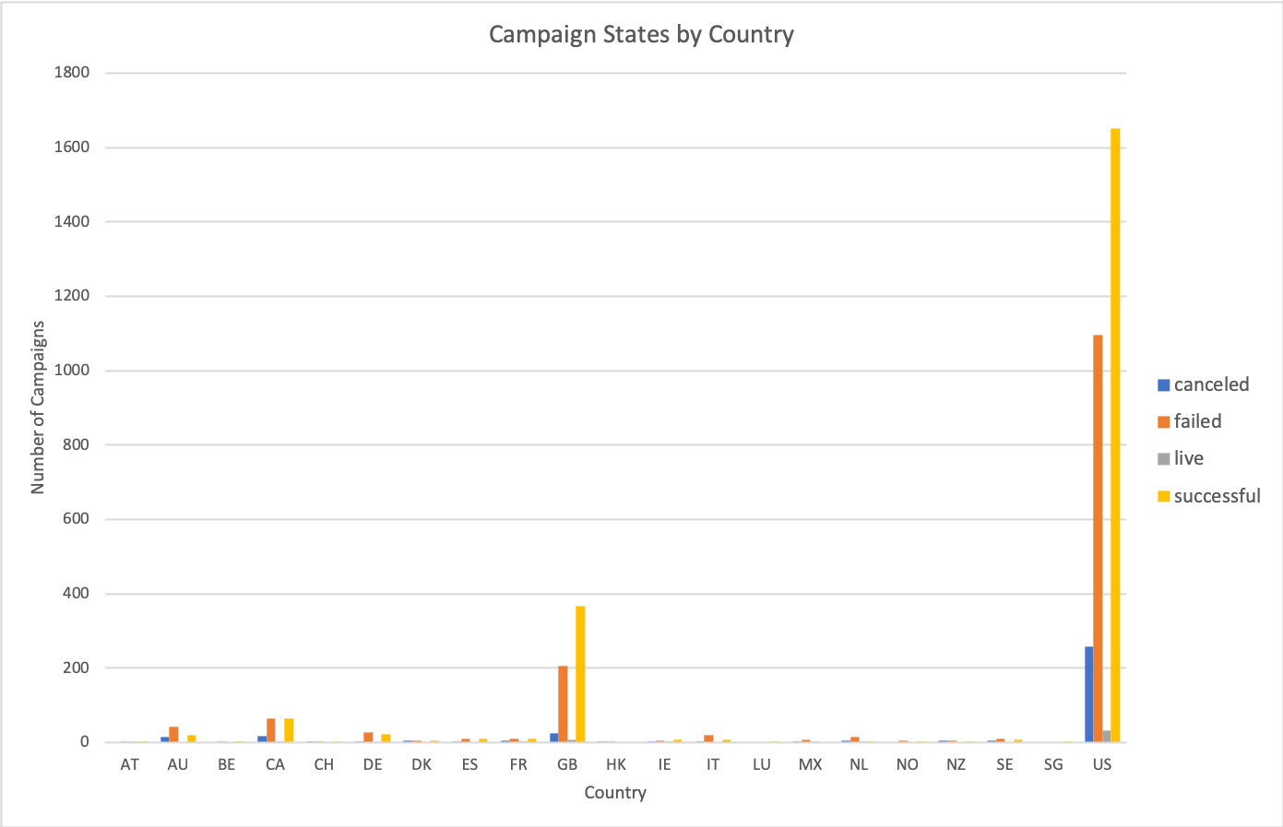

Figure 2:

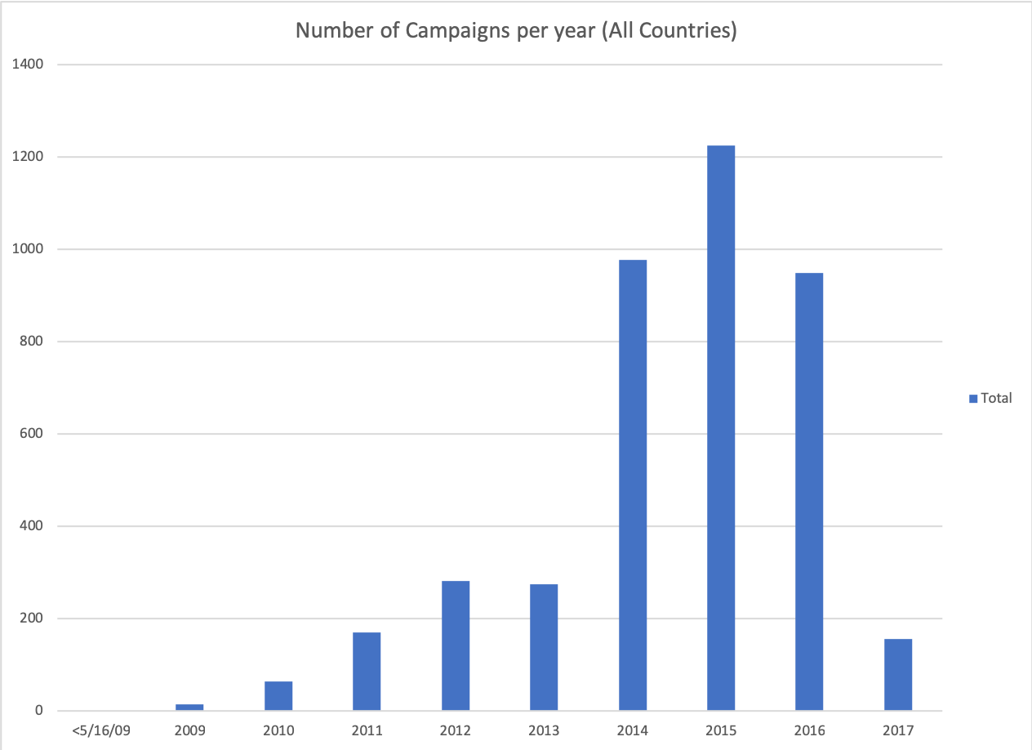

What are some of the limitations of this dataset?

There are a number of limitations, as even though Kickstarter data goes back as far as 2009, it appears that adoption by country is staggered. This may be due to a rollout plan that cannot be understood by the data provided, or slow acceptance. This means we cannot yet tell the longer term adoption of this method of crowdfunding and how it is used globally until more countries are using Kickstarter for a longer period of time.

Additionally, we can only calculate the mean campaign contribution. This does not show us what may really be taking place with regard to contributions by the majority. Meaning that one person may contribute $1000 to a campaign, for example, while 100 people may match that amount by contributing $10 each. Metrics to determine what reasonable amount a reasonable person would be willing to contribute to a campaign are not in the dataset. This also does not tell us what tier pricing does for contributions.

Perhaps the biggest thing, and perhaps also the least important, is that we cannot determine by any means what satisfaction level any given campaign achieved. Do people have buyer’s remorse? Did the deliverable undershoot, match or exceed the promise? Etc.

What are some other possible tables/graphs we could create?

I have already provided two examples in my answer to the first question of tables/graphs that were created. Some others include:

Which categories/sub-categories are most successful during which months?

What is the average number of days for success for a given category/sub-category.

What is the average number of days to gain an average dollar increment in a category (e.g. how long does it take on average to get $1000 funded for a Film & Video/Television project)?